Social Media Assignment: Photo Analyzation

All airlines monitor employees social media accounts. What you post online can have a great impact on your career. Posting inappropriate content can result is disciplinary actions, and in some cases dismissal from your employer. Not only do they monitor what you post, but they also monitor when you post it. As airline employees, we cannot post any content on duty. This mean from our report time to release time. As well as trainings and airlines facilities. Our jobs expose us to beautiful places and great experiences, but we must know how to display ourselves and our lifestyle on social media platforms.

Aside from what we post, passengers also record us and take photos of us in uniform at any time. Therefore, it is important to look the part, and always follow company policies and guidelines.

Learning Outcome
- Airlines social media guidelines
- Professionally and mindfully using social media

Analyze the photos provided below. Would you consider them appropriate to share on social media?

For each photo, label in the answer box APPROPRIATE or INAPPROPRIATE

Explain briefly but in detail the reasons why you would consider these photos to be appropriate/inappropriate in an video recording of yourself. If you are having difficulties creating and attaching an video, you may also use an voiceover.

This assignment is worth 20% of your final mark with an 2% achievement mark attached to it.

Please attach your video or voiceover as an separate file to the assignments tab.

Photo #1 Photo #2 Photo #3
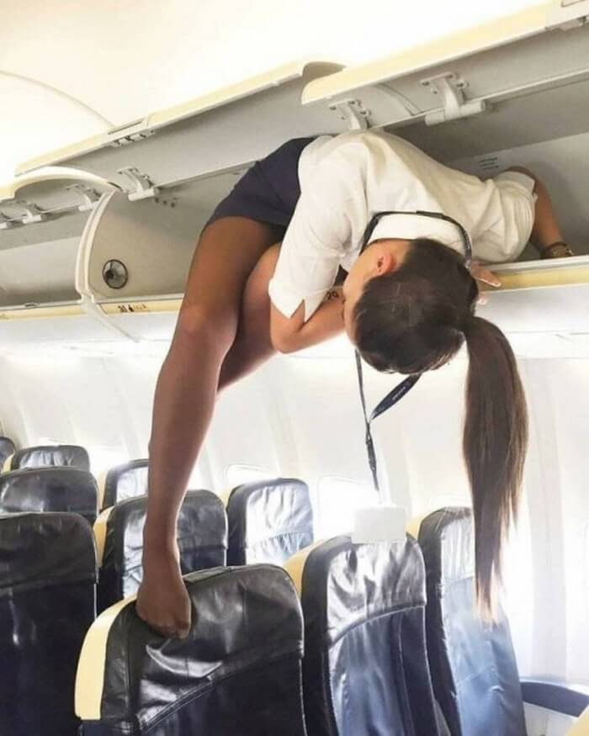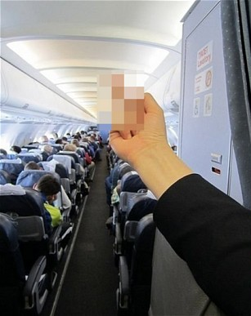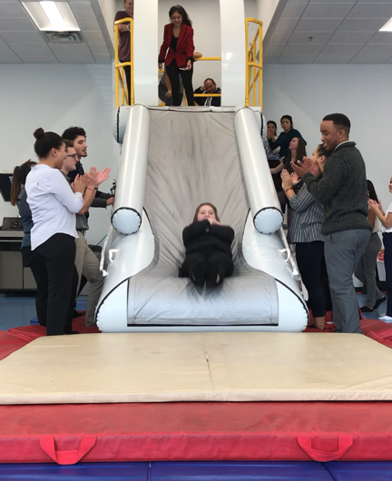
Answer:
Answer:
Answer:

Photo #4 Photo #5
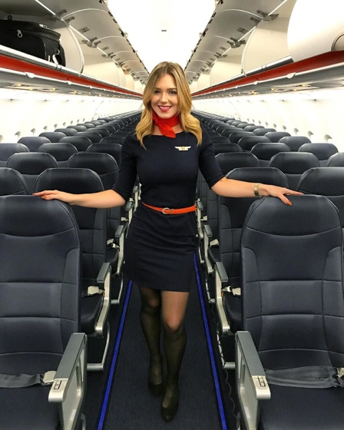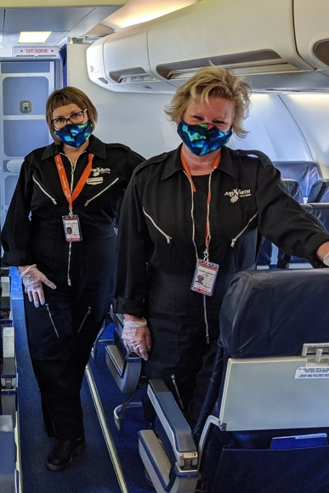

Answer:
Answer:

